# **“Project - Phase III: Dashboard Implementation**

Group Members: **Aathira Vazaiel Raghavan (1233857497),**

**Adhithi Sathish Kumar (1233343815),**

**Ishwariya Pandi (1233885850),**

**Vaishmitha Reddy Biyyapu (1233298757)**

**IFT 533: Data Visualization & Reporting for IT**

**PROF. ASMAA ELBADRAWY**

MAY 2nd, 2025”

**Table Of Contents:**

**Section 1: The Dashboard** 3

**Section 2: The Dataset** 4

**Section 3: Dashboard Users** 6

**Section 4: Questions** 8

**Section 5: Plots** 9

**Section 6: Interactivity** 24

**Tableau Public Link for Dashboard:** 26

# **Section 1: The Dashboard**

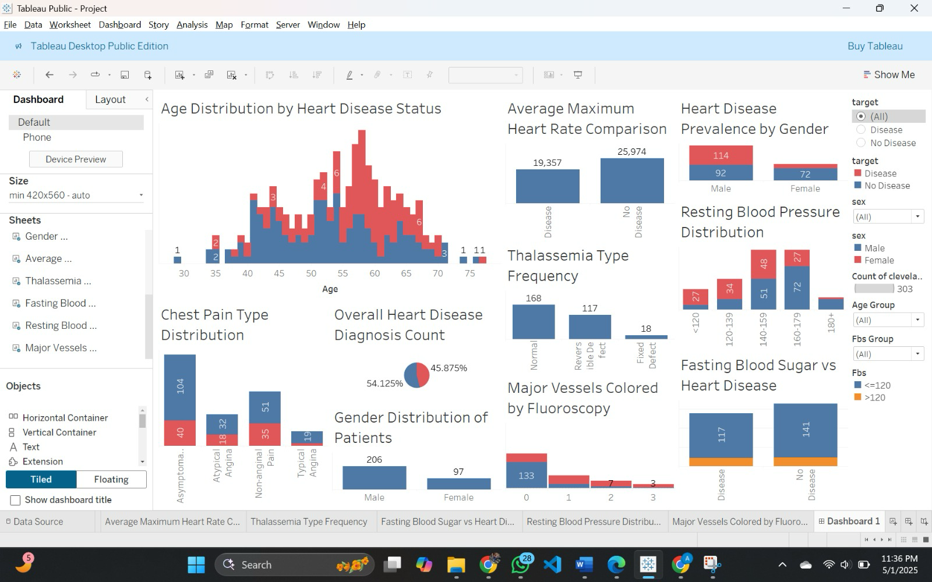

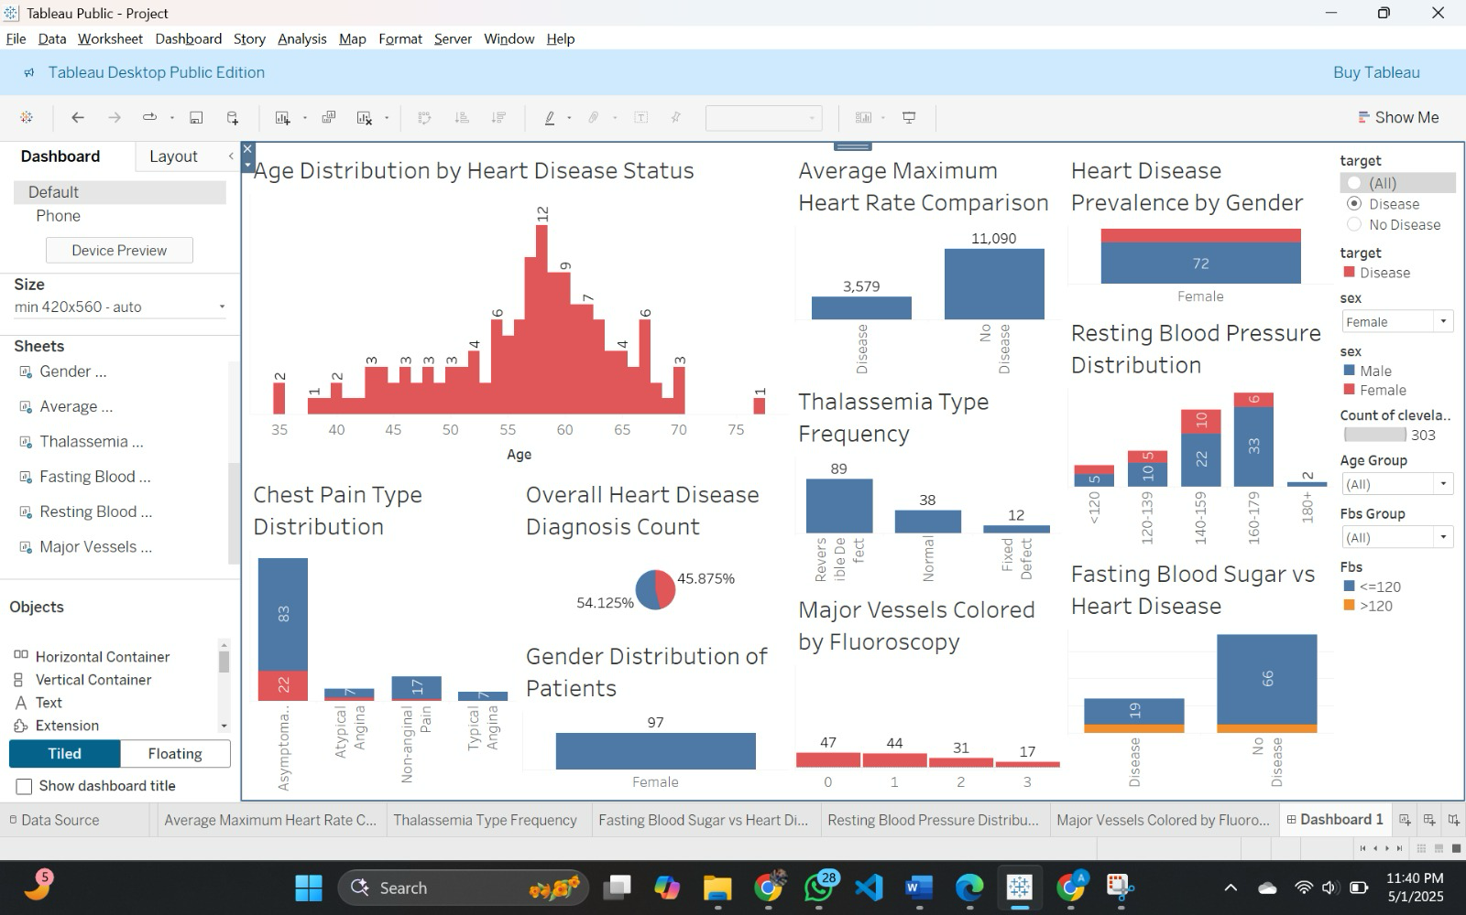

## **“A brief explanation for what it is used for”**

Using the Cleveland dataset, this interactive Tableau dashboard offers a thorough visual study of heart disease risk variables. It enables users to investigate the relationship between the presence or absence of heart disease and a number of characteristics, including age, gender, kind of chest discomfort, thalassemia type, resting blood pressure, fasting blood sugar level, and number of main vessels coloured by fluoroscopy. To dynamically update the visualizations and concentrate on particular subgroups of interest, users can apply filters such as age group (multi-select), gender (drop-down), heart disease status (single-value list), and fasting blood sugar group (drop-down). By allowing side-by-side comparisons between impacted and unaffected patients across a number of criteria, the dashboard facilitates data-driven insights. Finding patterns, evaluating trends, and better understanding the relationship between clinical markers and cardiac disease is especially helpful for researchers, doctors, and healthcare analysts. This will ultimately help with early identification and well-informed decision-making.

# **Section 2: The Dataset**

### **Dataset Explanation and Preprocessing Details**

The dataset used in this project is the **Cleveland Heart Disease dataset** from the **UCI Machine Learning Repository**, consisting of **303 patient records**. Each record contains **14 medical attributes**, which include both **numerical** and **categorical** variables related to cardiovascular health.

#### **Attributes in the Dataset:**

1. **age** – Age of the patient (numerical, ratio)
2. **sex** – Gender (0 = female, 1 = male)
3. **cp** – Chest pain type (categorical: 0–3)
4. **trestbps** – Resting blood pressure (numerical, mm Hg)
5. **chol** – Serum cholesterol (numerical, mg/dl)
6. **fbs** – Fasting blood sugar > 120 mg/dl (1 = true; 0 = false)
7. **restecg** – Resting electrocardiographic results (categorical)
8. **thalach** – Maximum heart rate achieved (numerical)
9. **exang** – Exercise-induced angina (1 = yes; 0 = no)
10. **oldpeak** – ST depression induced by exercise (numerical, float)
11. **slope** – Slope of the peak exercise ST segment (categorical: 0–2)
12. **ca** – Number of major vessels colored by fluoroscopy (0–3; can have missing values)
13. **thal** – Thalassemia (3 = normal; 6 = fixed defect; 7 = reversible defect; can have missing values)
14. **target** – Diagnosis of heart disease (0 = no disease; >0 = presence of disease)

**Preprocessing Steps Performed:**

#### 1. Handling Missing Values

* Detected missing values in thal and ca, marked as "?".
* Replaced "?" with NaN to enable proper handling.
* Performed two strategies:
  + **Row deletion** for records where imputation wasn't suitable.
  + **Mode imputation** (most frequent value) for fields where missing entries could be safely inferred.

#### 2. Data Type Correction

* Converted affected columns like ca and thal from string to proper **numerical types** (float/int) after handling missing values.
* Ensured that all nu**merical attributes** (e.g., age, chol, trestbps, thalach, oldpeak) were in **float/integer format**.
* Verified that **categorical attributes** (sex, cp, fbs, restecg, exang, slope, thal) remained in appropriate **integer formats**.

#### 3. Attribute Engineering

* Simplified the target variable into a **binary classification**:
  + 0 = No heart disease
  + 1 = Presence of heart disease (original values > 0)
* Transformed encoded values into **human-readable labels** for:
  + cp (e.g., typical angina, non-anginal pain)
  + slope (e.g., upsloping, flat, down sloping)
  + thal (e.g., normal, fixed defect, reversible defect)
* Created **additional groupings** such as:
  + **Age Groups** (e.g., 20–40, 41–60, 61+)
  + **Fasting Blood Sugar Groups** to support better filtering in Tableau

#### 4. Consistency Check

* Ensured all preprocessing steps resulted in:
  + No missing values remaining
  + All data types matching expected usage (categorical vs. ratio)
  + Attribute definitions aligning with the **Mural dashboard's encoding**
  + Correct mapping of ordinal vs. nominal categories

#### 6. Tool Usage

* Used **Tableau Prep Builder** for cleaning, reshaping, and preparing the dataset.
* Final dataset exported to **Tableau Desktop** for creating **interactive dashboards** using:
  + **Dashboard Actions** for user-driven filtering/highlighting
  + **Table Calculations** for running totals, rankings, and trend analyses

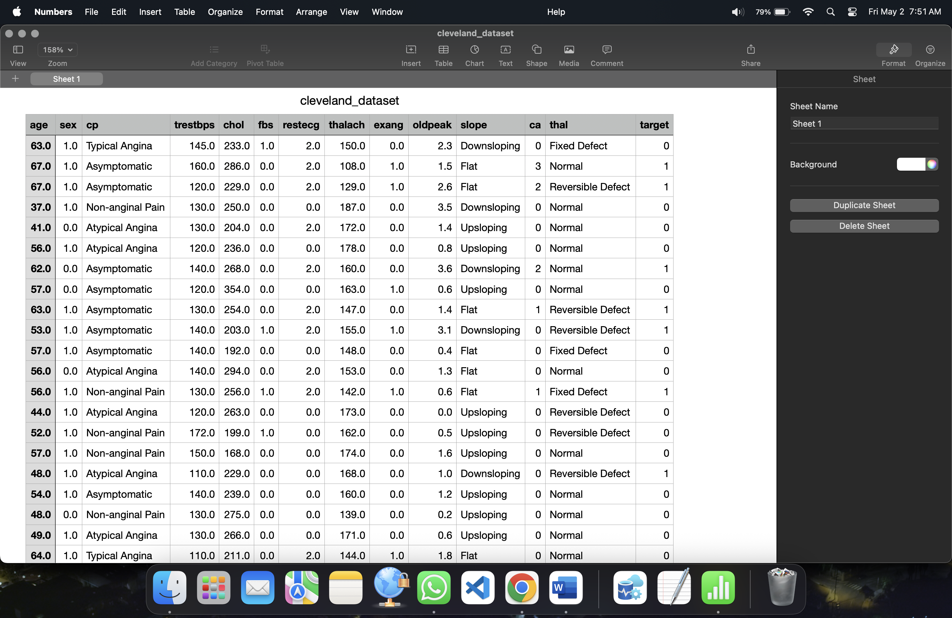

# **Section 3: Dashboard Users**

## **1. Cardiologists and Medical Practitioners**

* Identify which **age groups** are most at risk (Plot 1).
* Compare **heart disease rates between men and women** (Plot 2).
* Recognize which **chest pain types** are strongly linked with heart disease (Plot 3).
* Monitor how **resting blood pressure** and **heart rate** impact diagnosis (Plots 6 & 9).
* Use insights from **fasting blood sugar** and **major vessels** data to inform treatment (Plots 8 & 10).
* Leverage thalassemia types and patient counts (Plots 4 & 7) to tailor diagnostic focus.

## **2. Healthcare Administrators and Policy Makers**

* Understand **population-level risk trends** like age and gender-based disease prevalence (Plots 1 & 2).
* Use **diagnosis counts** (Plot 4) to gauge disease burden and allocate resources.
* Analyze **chest pain types and thalassemia frequencies** to inform screening guidelines (Plots 3 & 7).
* Guide public health messaging on **fasting sugar risks** (Plot 8).
* Design **interventions** targeting high-risk BP groups or regions (Plots 9 & 10).
* Assess gender distribution for inclusive healthcare planning (Plot 5).

## **3. Medical Researchers and Data Analysts**

* Investigate **statistical relationships** between heart disease and factors like age, gender, BP, and heart rate (Plots 1, 2, 6, 9).
* Identify **most predictive features** (e.g., chest pain, thalassemia, major vessels) for model building (Plots 3, 7, 10).
* Segment data by **fasting blood sugar** and gender to validate hypotheses (Plots 2, 8).
* Use disease counts (Plot 4) to balance datasets for classification models.
* Analyze variance in **categorical vs continuous attributes** to optimize model performance.

## **4. Insurance Analysts**

* Assess risk categories by age and gender for underwriting (Plots 1, 2, 5).
* Evaluate how factors like chest pain and heart rate influence claim likelihood (Plots 3, 6).
* Use diagnosis distribution (Plot 4) to profile applicants.
* Analyze risks associated with high blood pressure, blood sugar, and vessel blockage (Plots 8, 9, 10).
* Use thalassemia patterns to consider long-term cardiac risk (Plot 7).
* Identify trends to support personalized premium structures and client stratification.

# **Section 4: Questions**

### 1. What is the age distribution of patients diagnosed with heart disease compared to those without?

### 2. How does heart disease prevalence differ between male and female patients?

### 3. What are the most common chest pain types among patients with and without heart disease?

### 4. How many patients in the dataset are diagnosed with heart disease, and how many are not?

### 5. What is the gender distribution of all patients in the dataset?

### 6. What is the average maximum heart rate for patients with heart disease compared to those without?

### 7. Which thalassemia types are most frequently observed among patients with heart disease?

### 8. How many patients with fasting blood sugar greater than 120 mg/dL have heart disease compared to those who do not?

### 9. What is the distribution of resting blood pressure among patients with and without heart disease?

### 10. How does the number of major vessels colored by fluoroscopy vary between patients with and without heart disease?

# **Section 5: Plots**

## **Plot 1: Age Distribution by Heart Disease Status**

Question: What is the age distribution of patients diagnosed with heart disease compared to those without?

How it addressed:

This bar chart presents patient numbers by age on the X-axis and heart disease status on the Y-axis in colored bars. There is a filter to view by disease presence. It is easily able to identify age groups with higher rates of heart disease and allows for easy comparison between those with and without the disease. Blue color is used to represent No Diseases and Red is used to represent Diseases

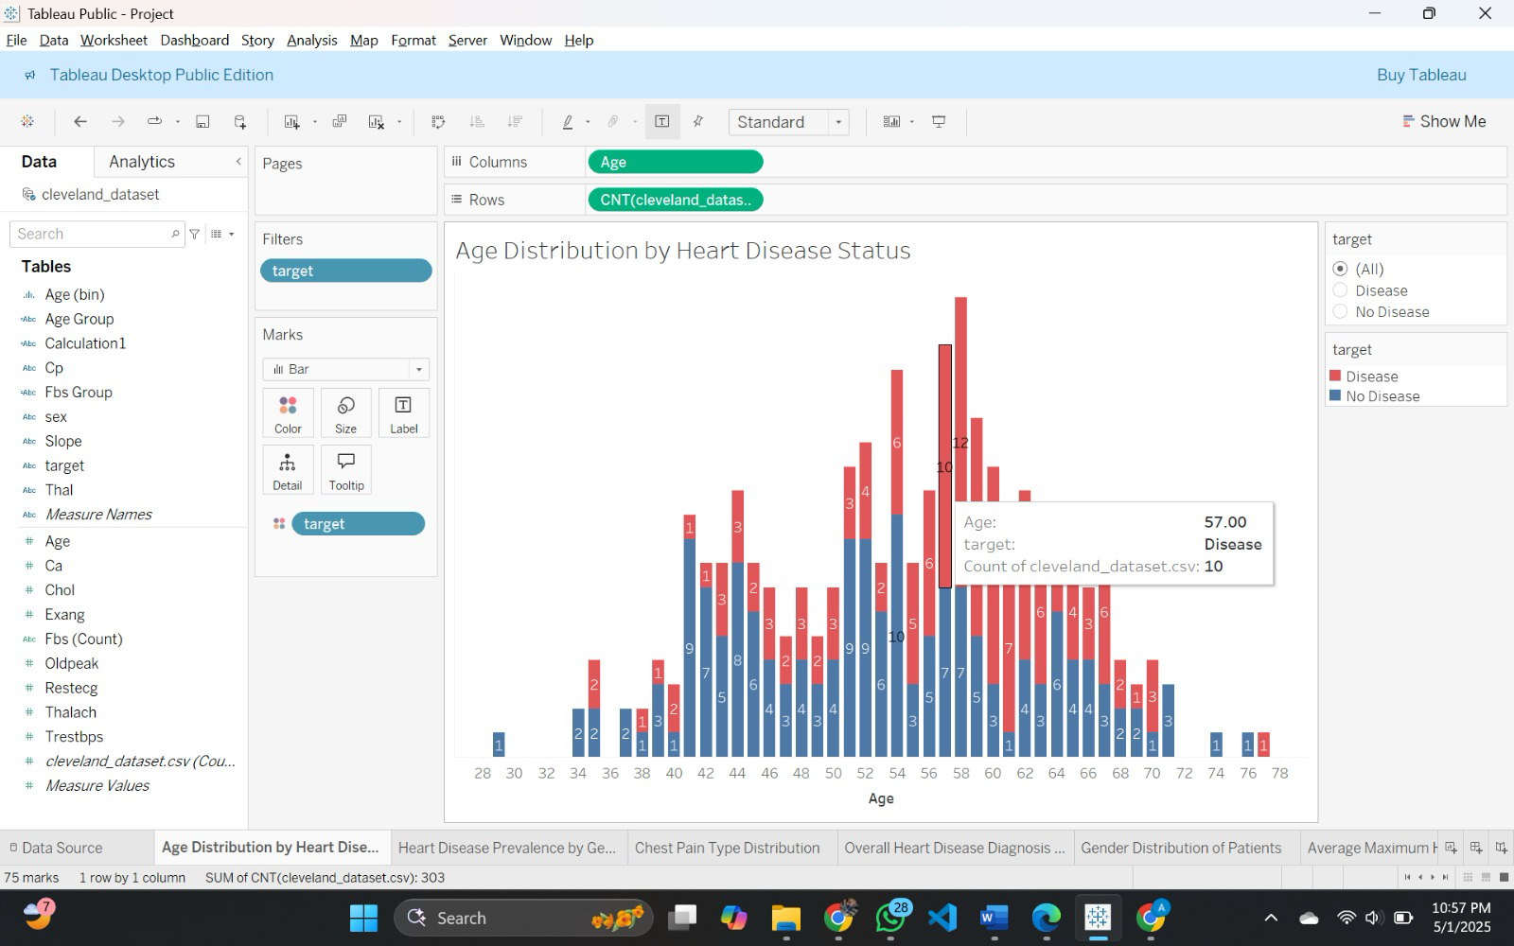

“Table Calculations:”

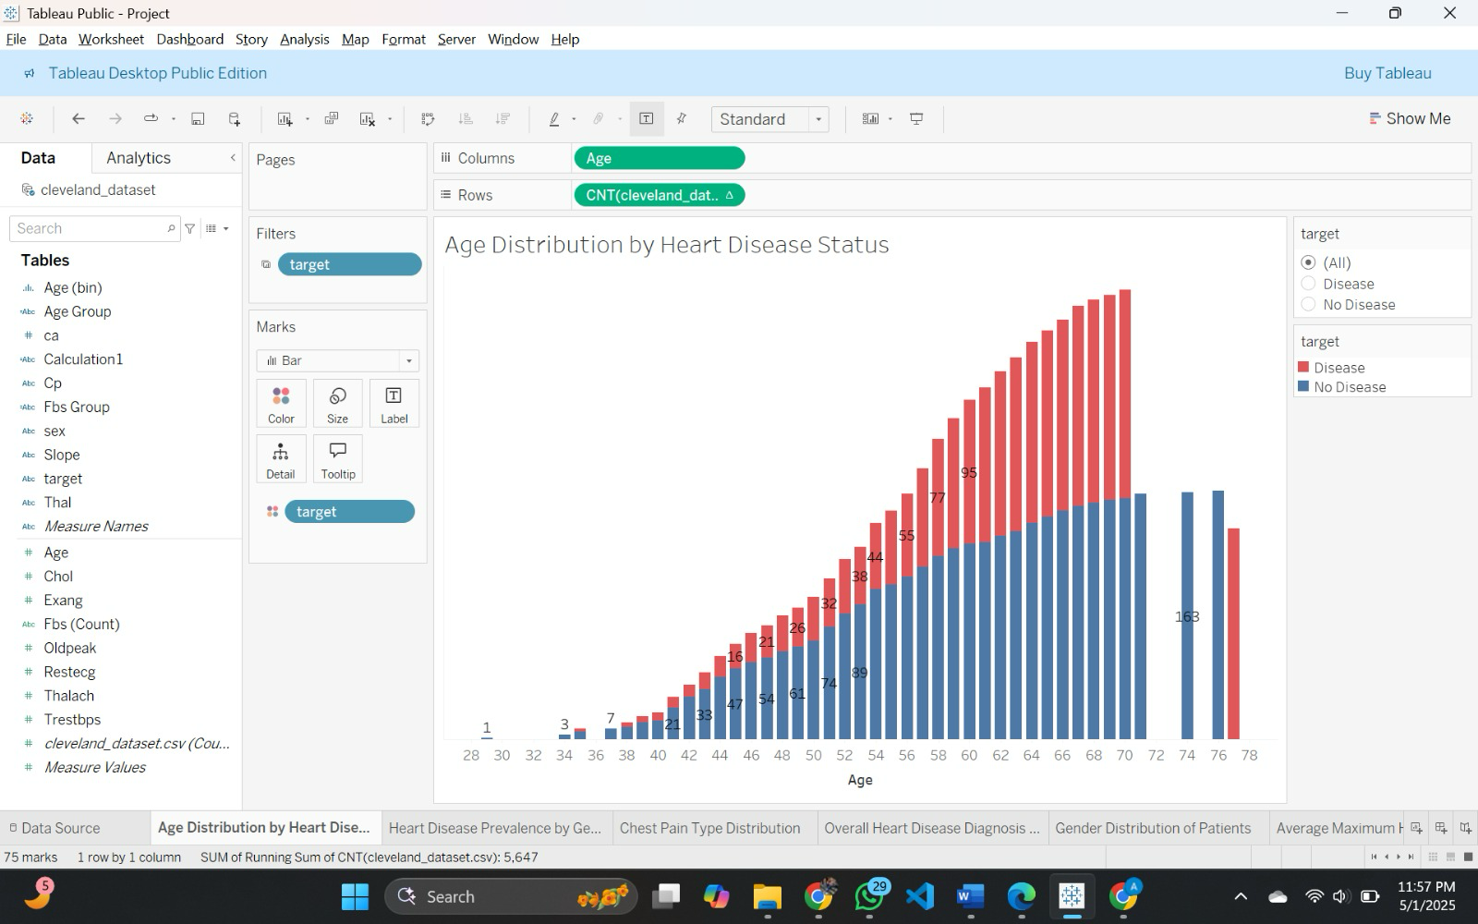

Use of table calculation:

The cumulative number of patients by age is shown in the graph using the running total table computation, which helps to show how the patient population grows over time and highlights age groups where the prevalence of heart disease rises significantly. Better insights into screening needs and healthcare decision-making are supported by the ability to clearly compare how patients with and without heart disease accumulate over a range of ages when the bars are stacked according to heart disease status.

“To show interactivity:”

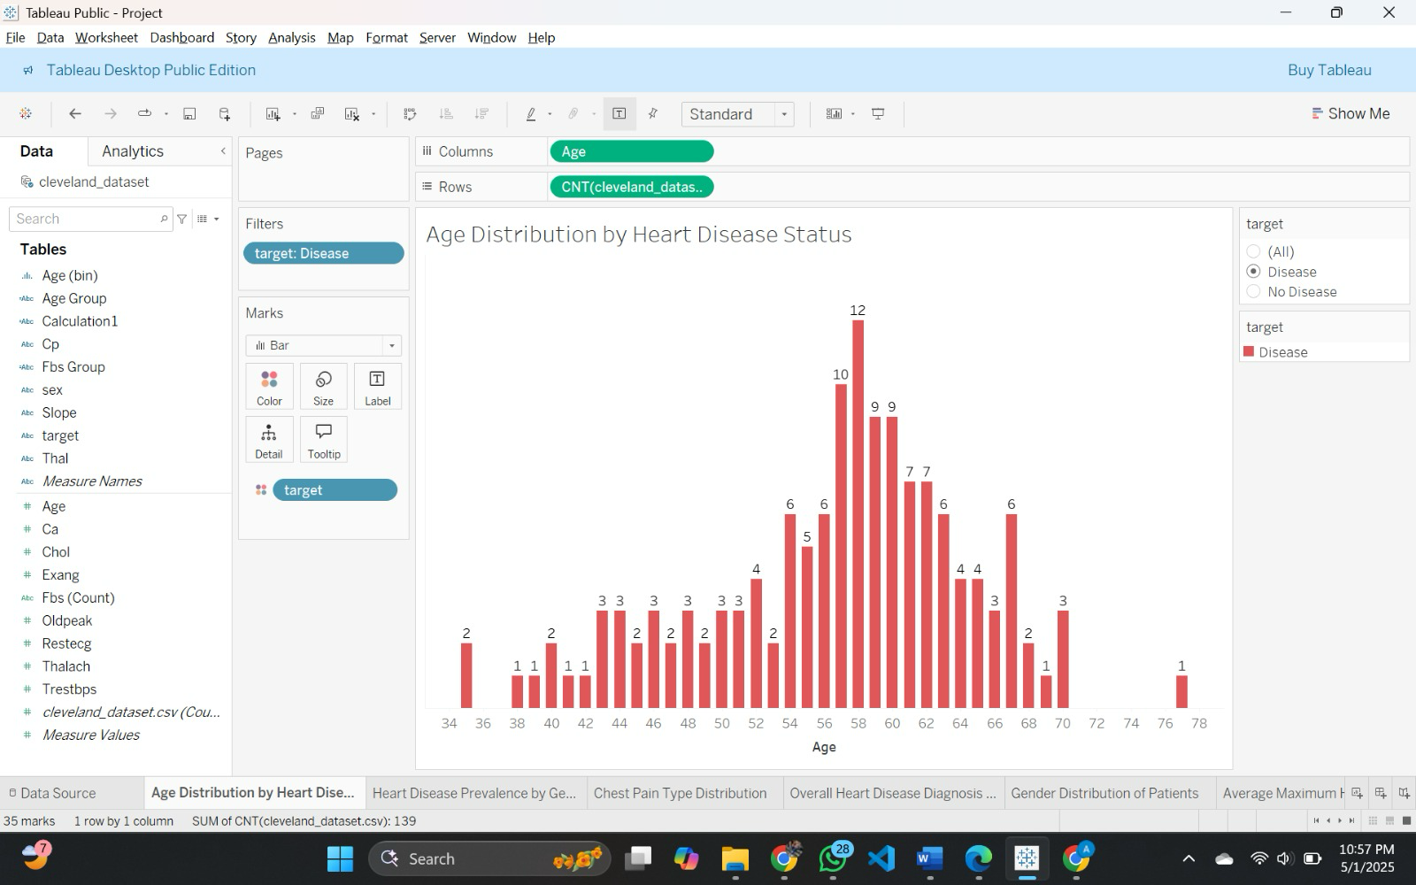

## **Plot 2: Heart Disease Prevalence by Gender**

### Question: How does heart disease prevalence differ between male and female patients?

How it addressed:

This vertical stacked bar graph uses gender on the X-axis and patient number on the Y-axis. Color—a powerful preattentive attribute—difference creates heart disease status: red for disease, blue for no disease. Height and position enable observers to compare easily prevalence with greater disease numbers in men and strong visual discrimination by color.

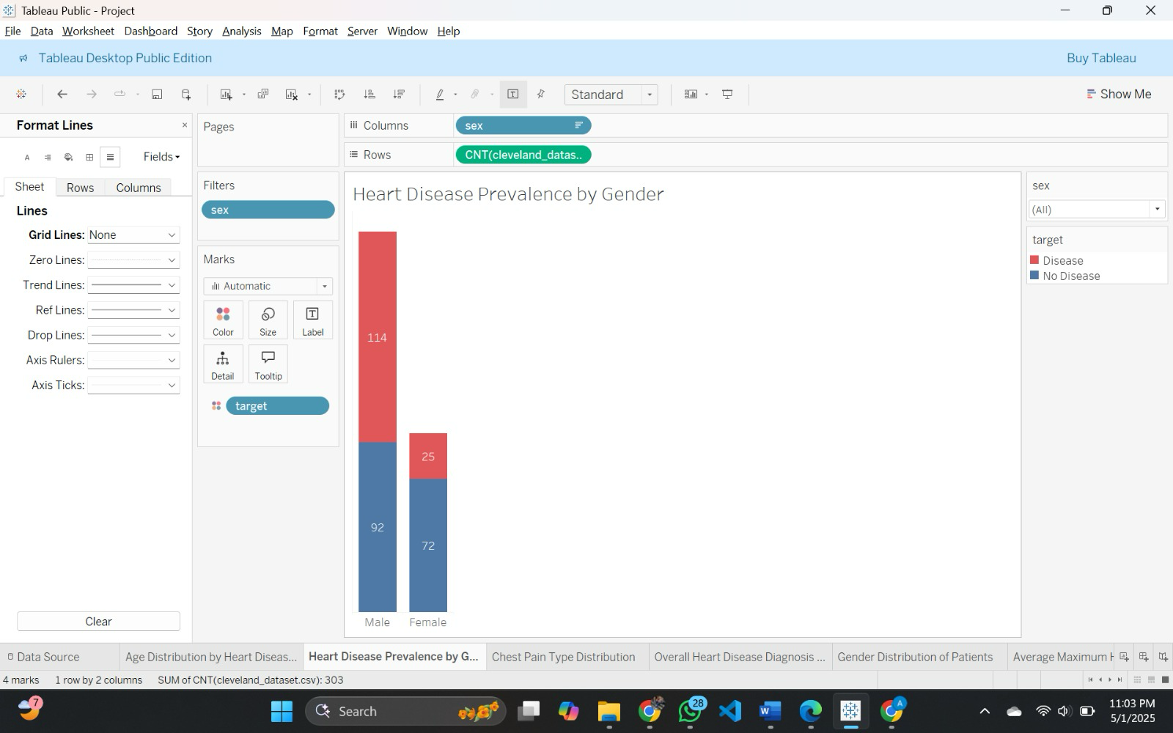

“To show interactivity:”

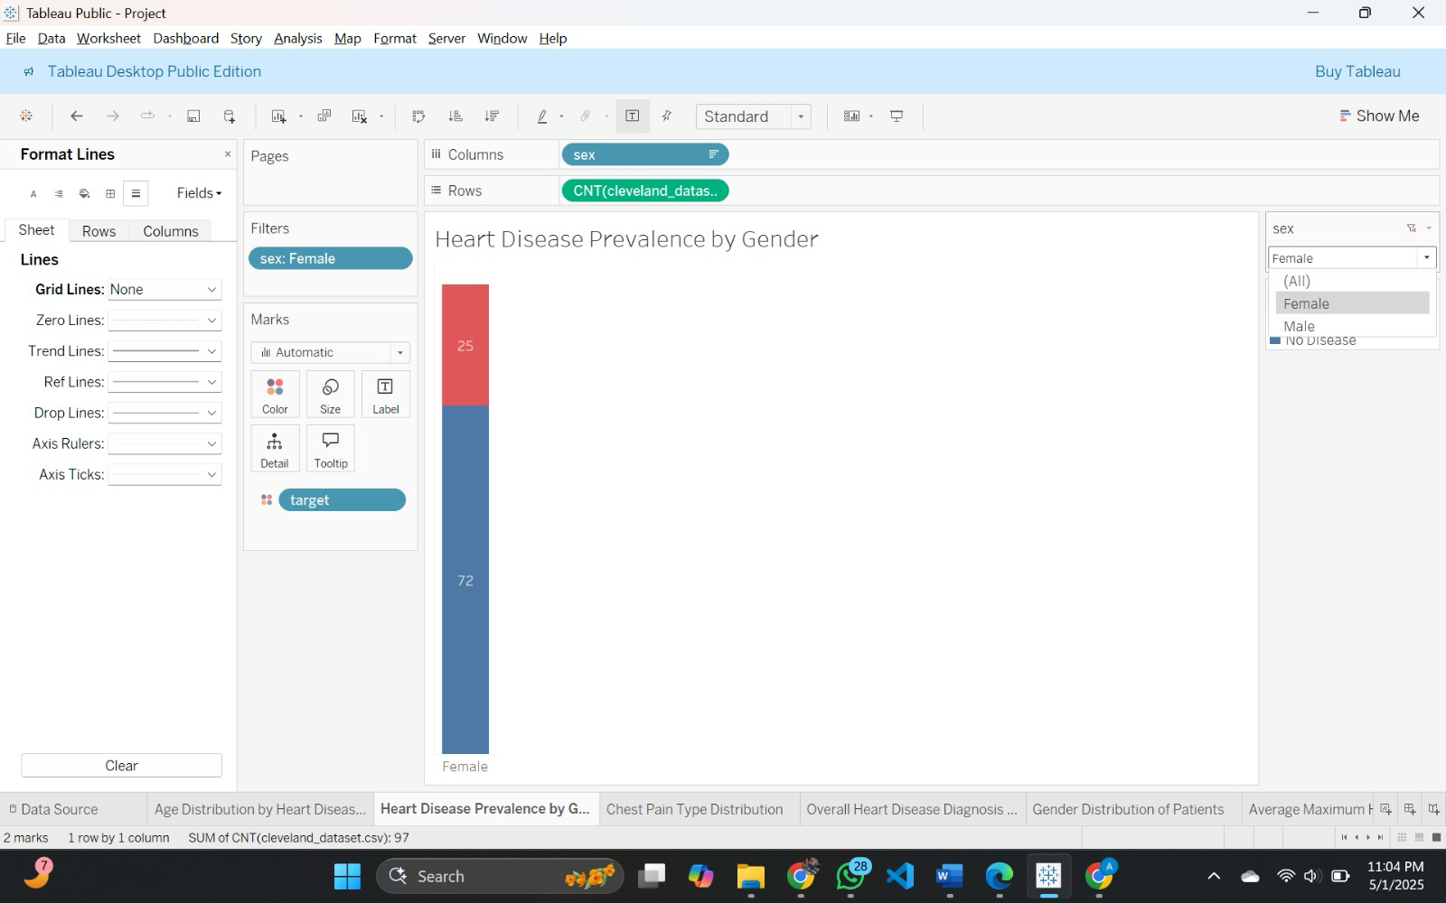

## **Plot 3: Chest Pain Type Distribution**

### Question: What are the most common chest pain types among patients with and without heart disease?

How it addressed:

This stacked bar graph utilizes types of pain on the X-axis and patient number on the Y-axis. Color, as a crucial preattentive aspect, separates gender—blue for male, red for female—enabling easy comparison. Asymptomatic pain appears high in height and position as the most frequent type, especially in heart disease, making fast visual scanning feasible.

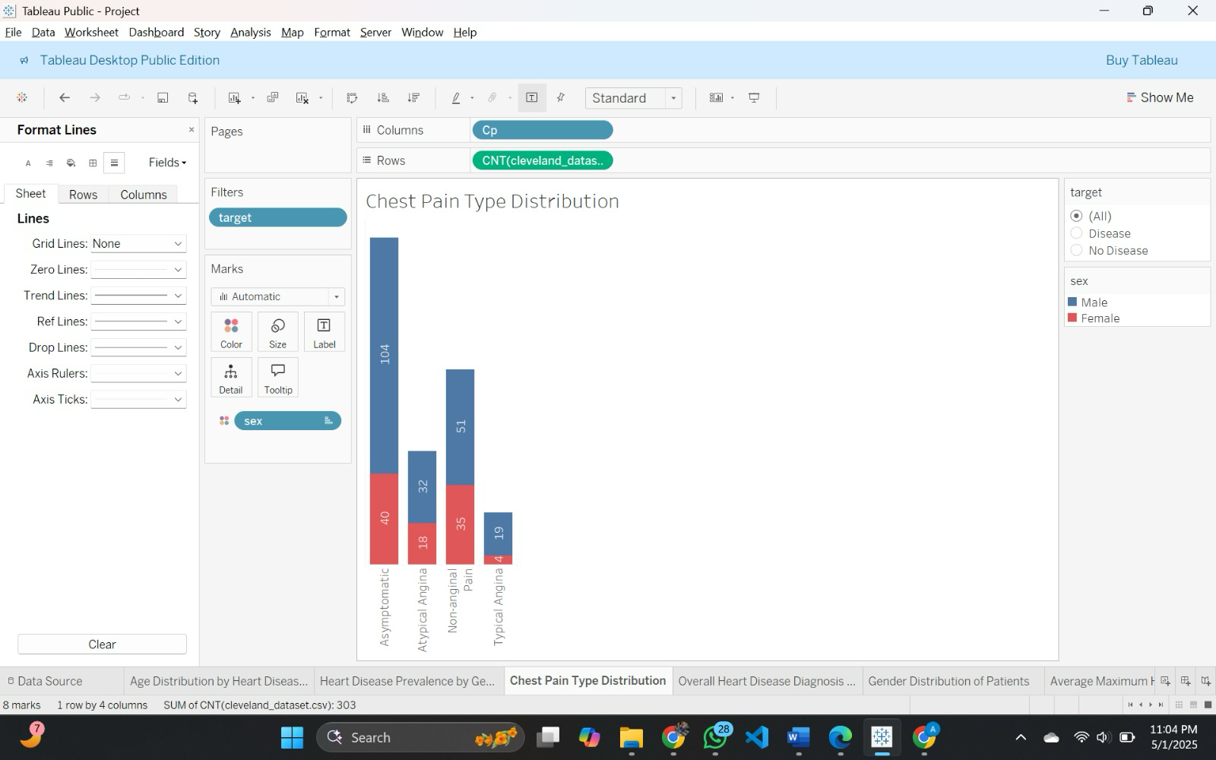

“To show interactivity:”

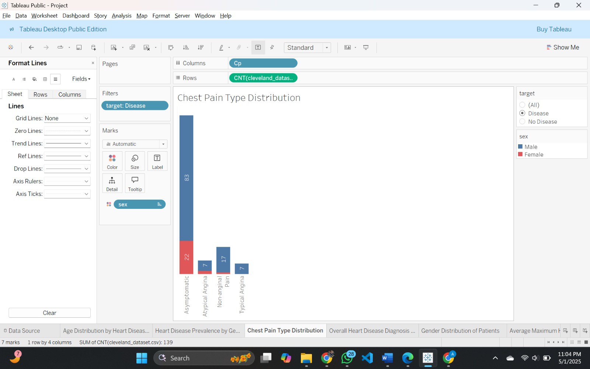

## **Plot 4: Overall Heart Disease Diagnosis Count**

### Question: How many patients in the dataset are diagnosed with heart disease, and how many are not?

How it addressed:

This pie chart uses angle and area-strong preattentive features-to graphically represent heart disease presence percentages. Disease patients are colored red and nondisease is blue. Percentage marks and color contrast allow for immediate understanding, with it being easily clear that 45.88% suffer from heart disease and 54.13% do not.

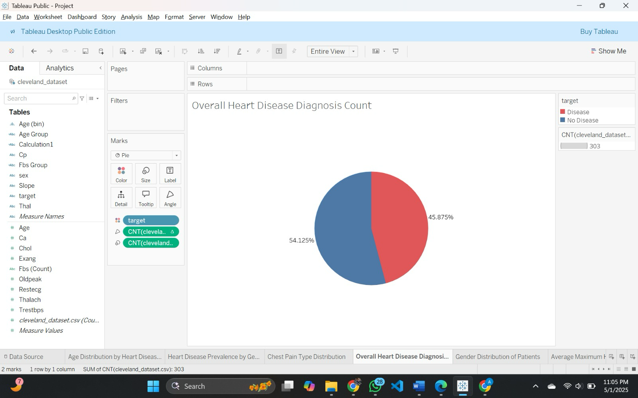

## **Plot 5: Gender Distribution of Patients**

### Question: What is the gender distribution of all patients in the dataset?

How it addressed:

This vertical bar chart plots gender along the X-axis and patient number along the Y-axis. Height—a preattentive feature—enables instant value comparison at a glance. Consistent blue color maintains focus on quantity rather than category. The graph strongly suggests more male (206) than female (97) patients in the data set.

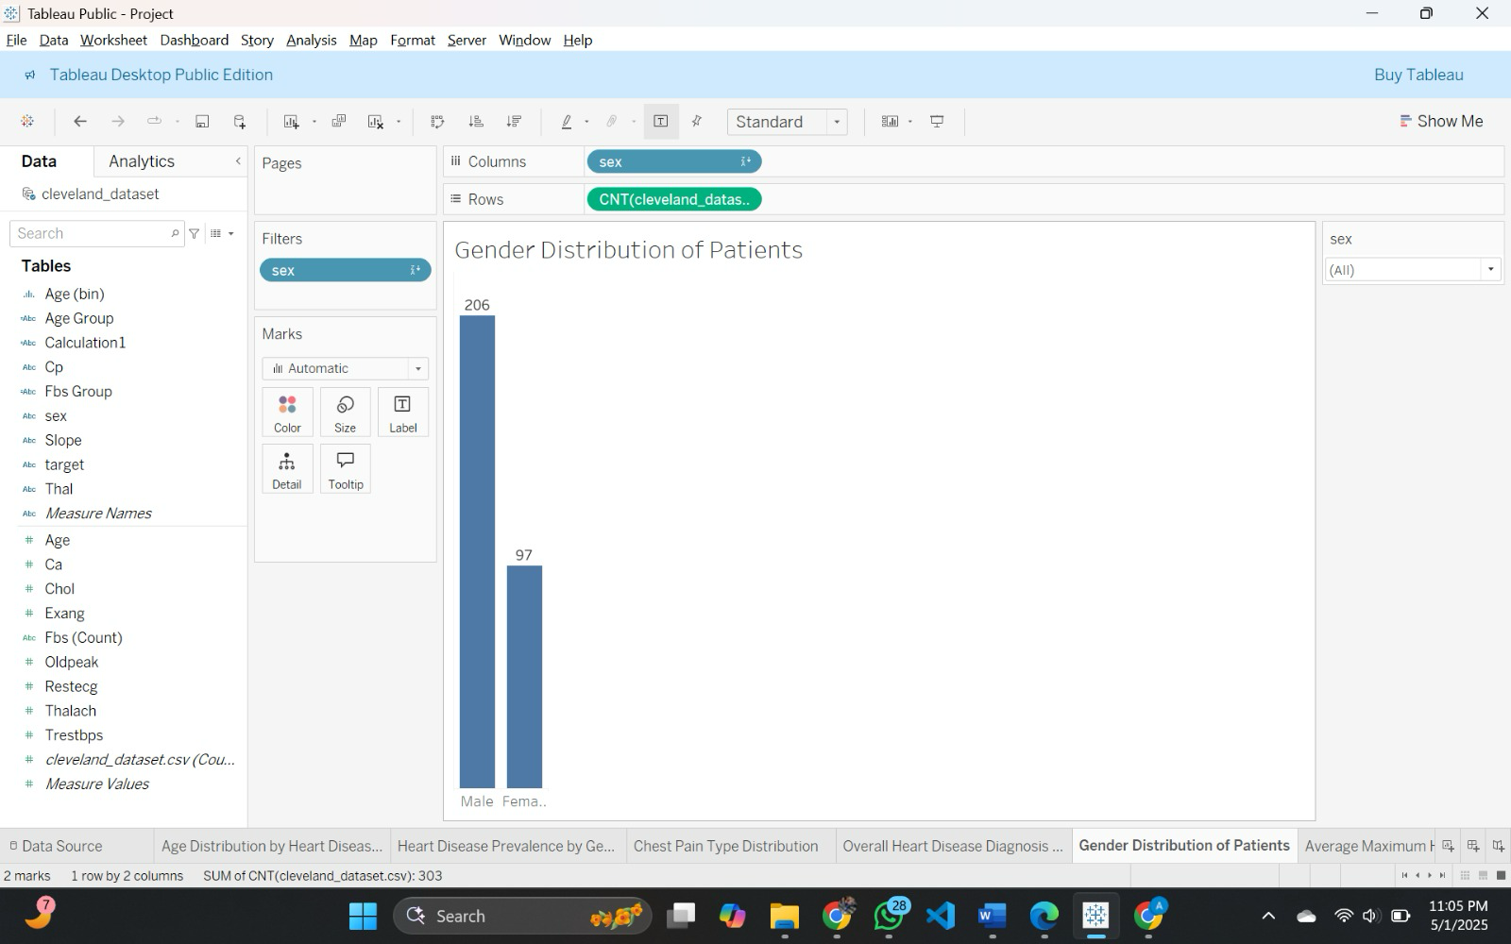

## **Plot 6: Average Maximum Heart Rate Comparison**

### Question: What is the average maximum heart rate for patients with heart disease compared to those without?

How it addressed:

This bar chart contrasts heart disease status on the X-axis and overall maximum heart rate on the Y-axis. The powerful preattentive feature of height allows quick comparison—showing higher average heart rates in patients with no heart disease. Equal color focuses attention on value difference, rather than category, and enhances clarity and interpretation.

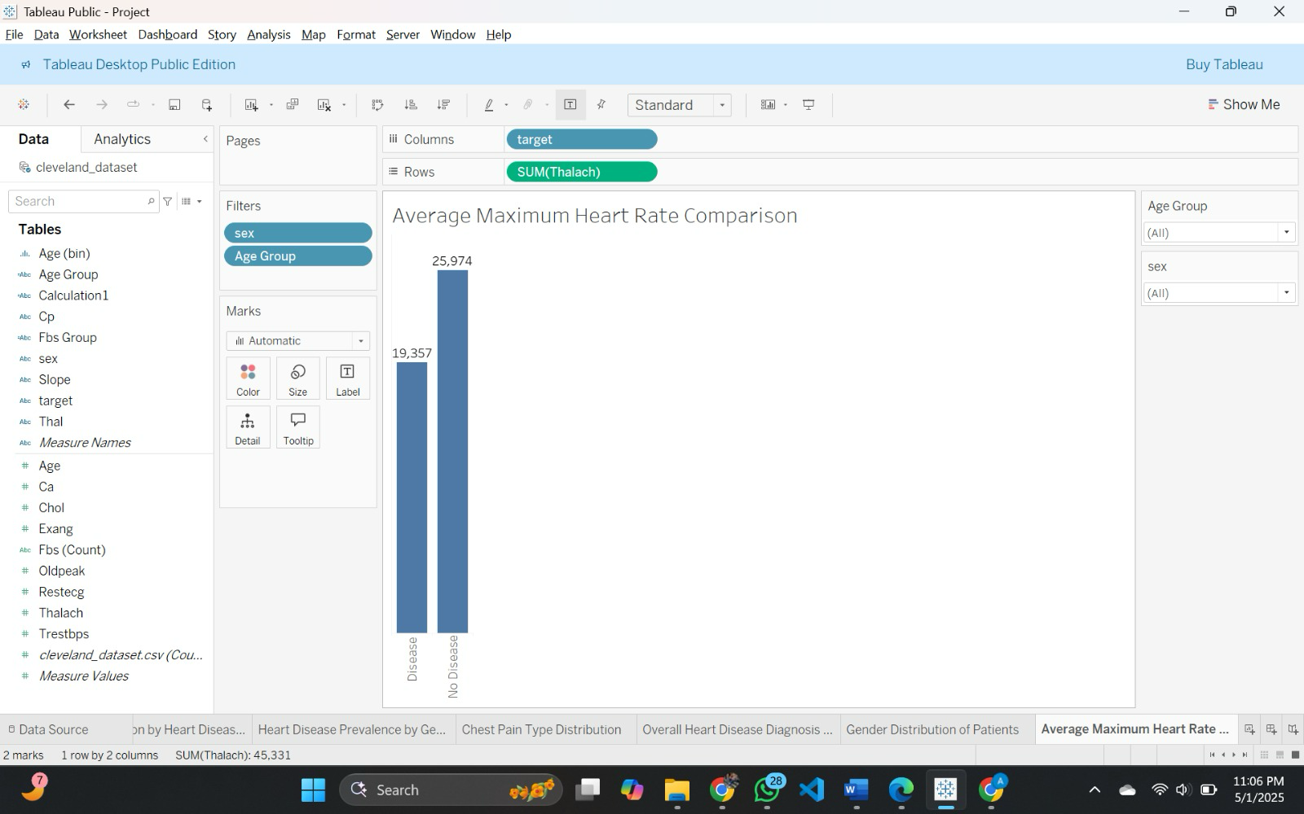

“To show interactivity:”

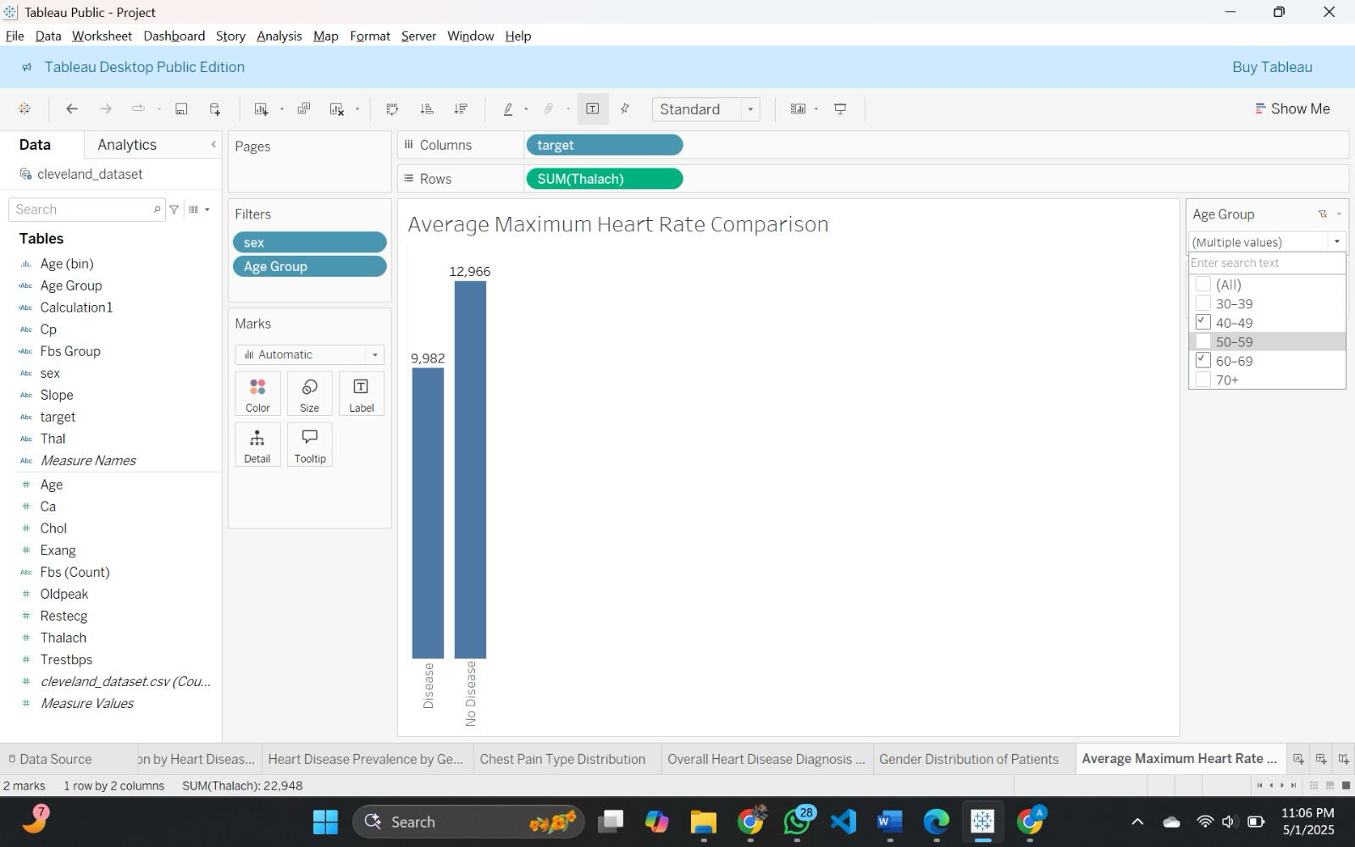

## **Plot 7: Thalassemia Type Frequency**

### Question: Which thalassemia types are most frequently observed among patients with heart disease?

How it addressed:

This bar chart uses thalassemia type along the X-axis and patient number along the Y-axis. Height, an influential preattentive property, makes comparison between frequencies straightforward. Uniform color directs attention towards differences in value. It shows that "Reversible Defect" is the most common thalassemia type in patients with heart disease.

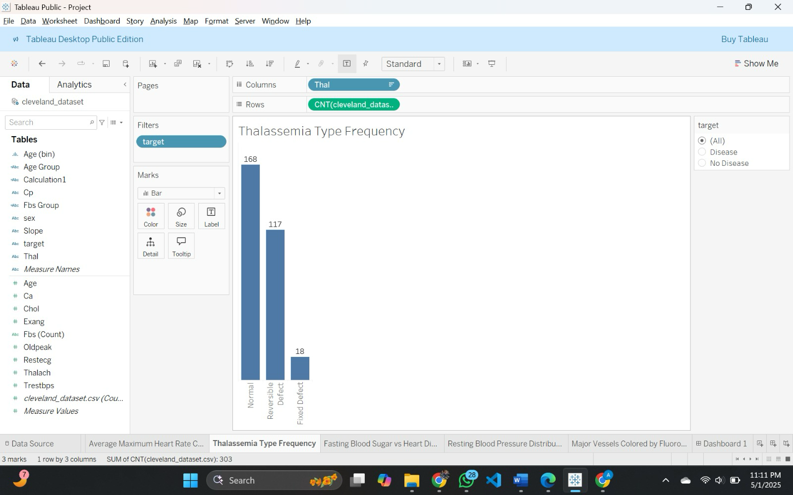

“To show interactivity:”

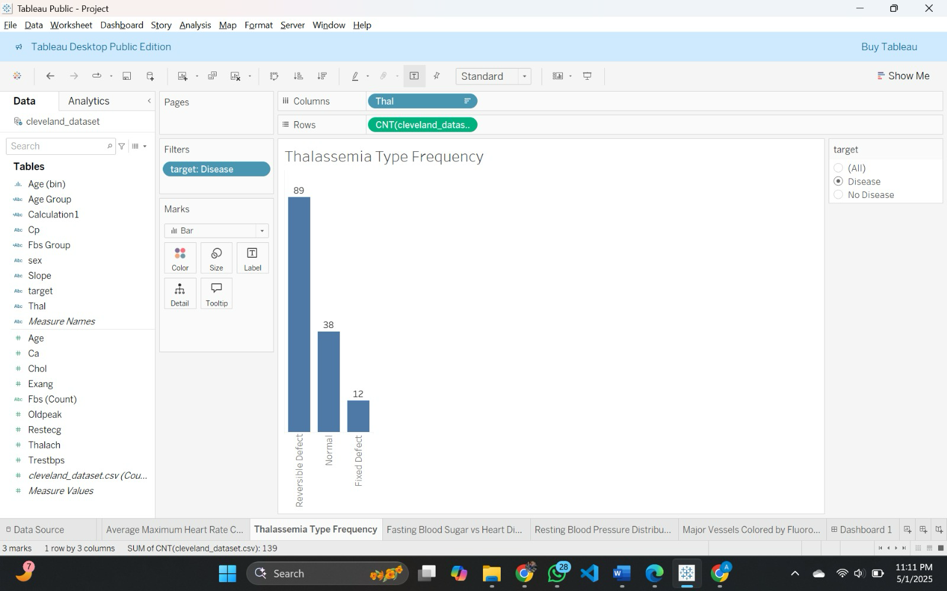

## **Plot 8: Fasting Blood Sugar vs Heart Disease**

### Question: How many patients with fasting blood sugar greater than 120 mg/dL have heart disease compared to those who do not?

How it addressed:

This stacked bar plot graphs heart disease status on the X-axis and number of patients on the Y-axis. Color, a desirable preattentive attribute, separates fasting blood sugar levels: ≤120 mg/dL is indicated in blue and >120 mg/dL in orange. It clearly shows that most patients, regardless of disease status, have lower fasting blood sugar.

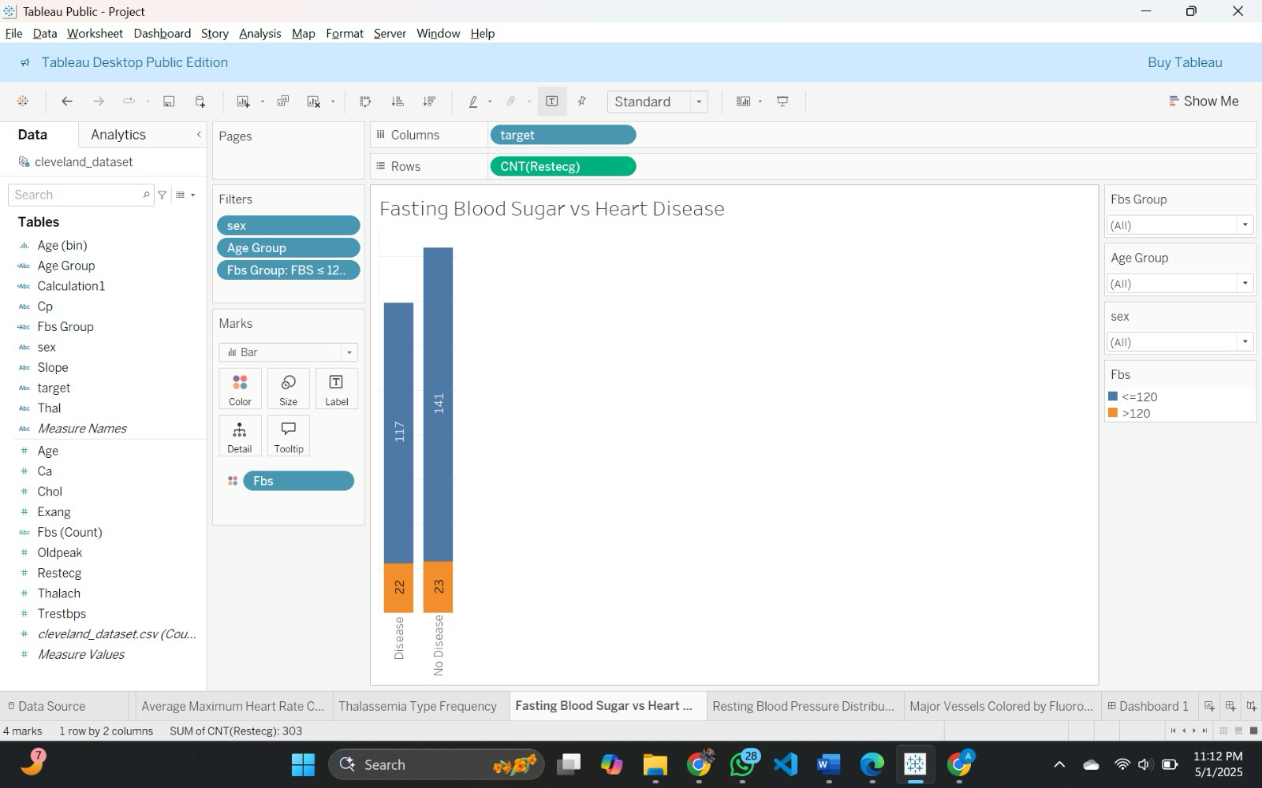

“To show interactivity:”

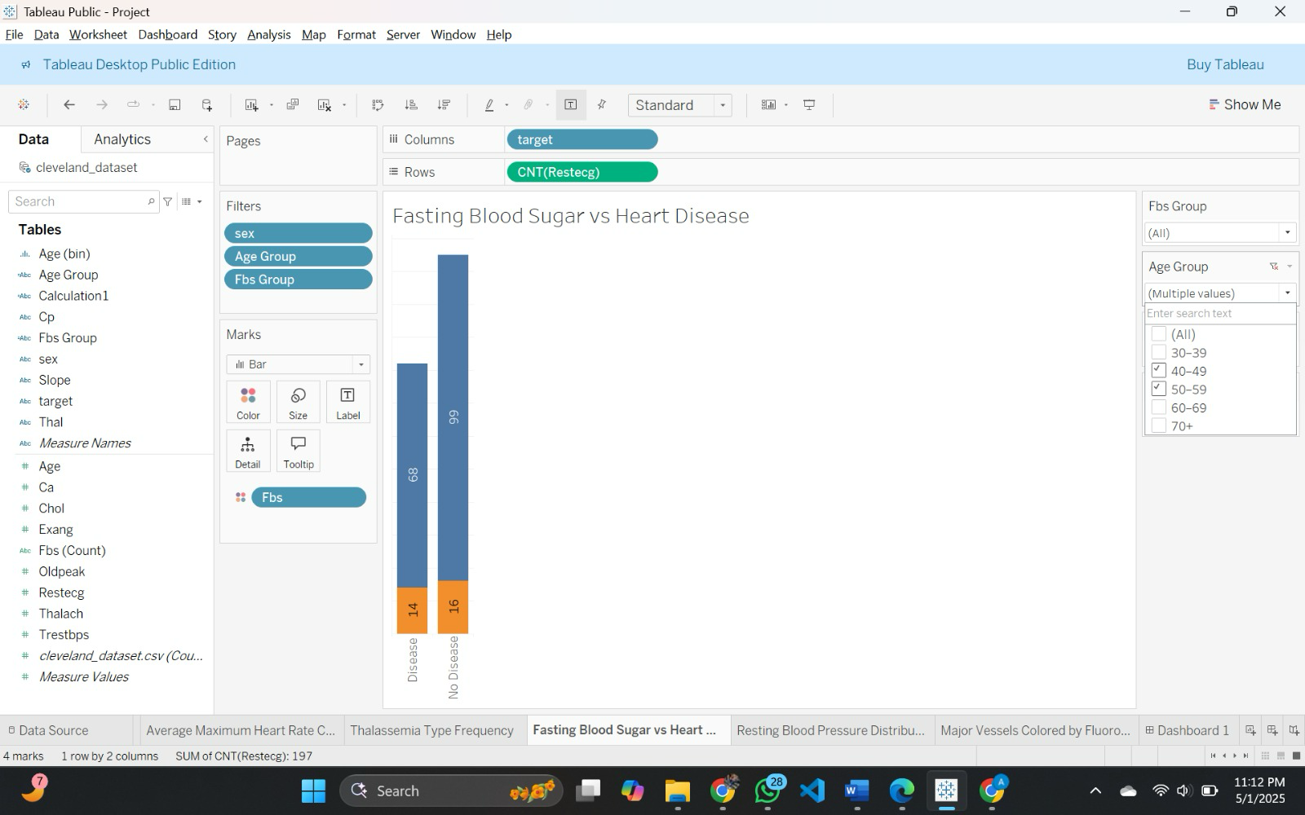

**Plot 9: Resting Blood Pressure Distribution**

### Question: What is the distribution of resting blood pressure among patients with and without heart disease?

How it addressed:

This stack bar chart displays ranges of blood pressure on the X-axis and number of patients on the Y-axis. Color—disease in red, no disease in blue—is a preattentive distinction to distinguish heart disease status. Bar height and difference in colors at once indicate that the 140–159 mmHg range is prevalent in both groups.

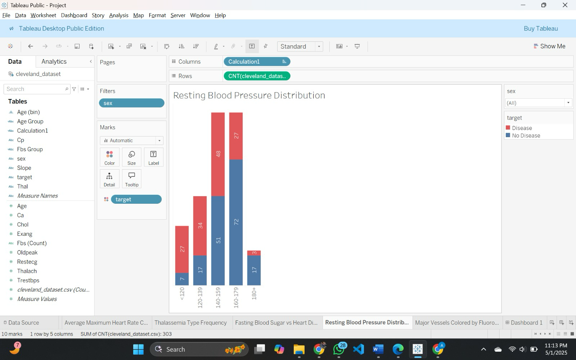

“To show interactivity:”

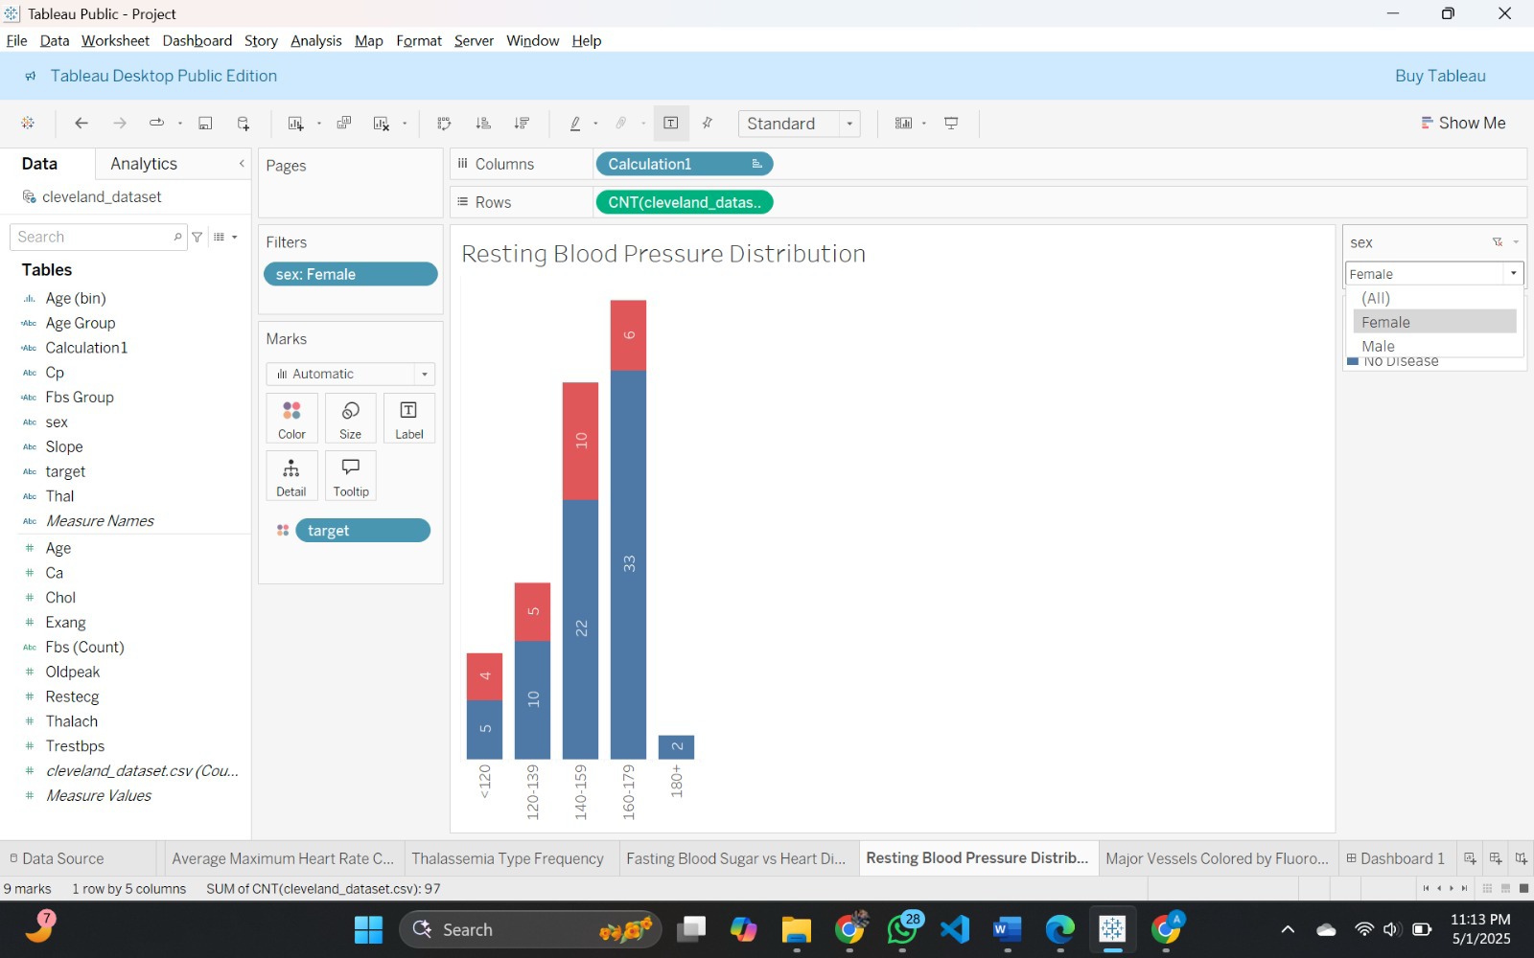

## **Plot 10: Major Vessels Colored by Fluoroscopy**

### Question: How does the number of major vessels colored by fluoroscopy vary between patients with and without heart disease?

How it addressed:

This stacked bar graph shows vessel quantity (X-axis) and number of patients (Y-axis) using color as a preattentive feature—disease red, no disease blue. Height and saturation immediately communicate that the heart disease patients have the majority of the vessels colored over (1–3), while the no-disease patients have the majority of them at 0.

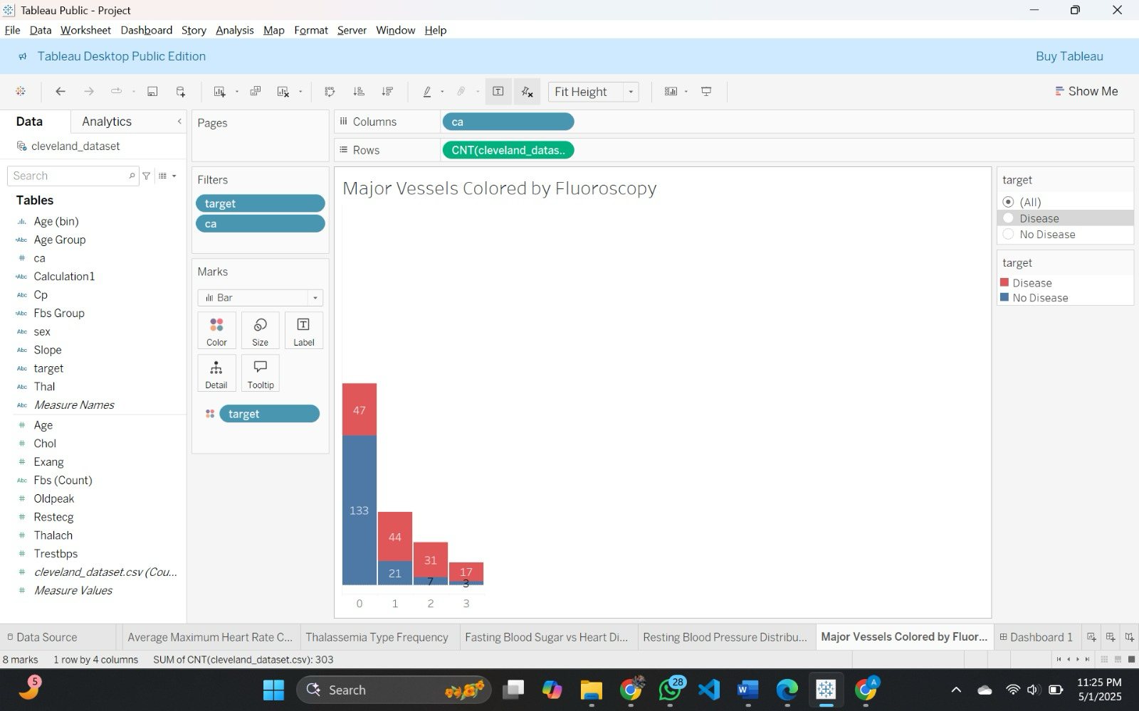

“To show interactivity:”

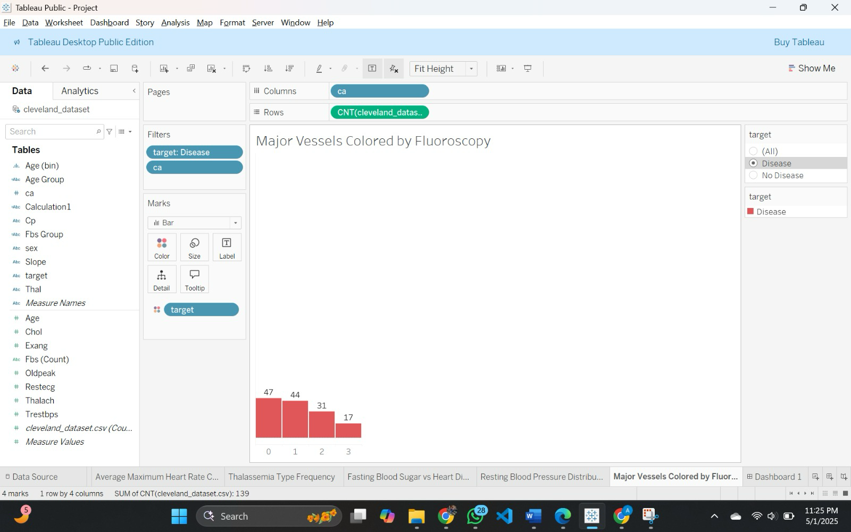

# **Section 6: Interactivity**

## **List Of Interactive Control:**

**Heart Disease Status Filter**• Used for: Filtering based on presence or absence of heart disease  
• Connected to:  
  – Plot 1: Age Distribution by Heart Disease Status  
  – Plot 3: Chest Pain Type Distribution  
  – Plot 7: Thalassemia Type Frequency  
  – Plot 10: Major Vessels Colored by Fluoroscopy

• Functionality: Filters the dashboard to display data **only for patients with or without heart disease,** enabling targeted analysis across related plots.  
• Value Range: Heart Disease, No Heart Disease  
• Loaded from: target attribute

**Gender Filter**  
• Used for: Exploring gender-specific trends  
• Connected to:  
  – Plot 2: Heart Disease Prevalence by Gender  
  – Plot 5: Gender Distribution of Patients  
  – Plot 6: Average Maximum Heart Rate Comparison  
  – Plot 8: Fasting Blood Sugar vs Heart Disease  
  – Plot 9: Resting Blood Pressure Distribution

• Functionality: Displays gender-specific insights by showing data **only for male or female patients,** helping explore sex-based patterns in heart disease.  
• Value Range: Male, Female  
• Loaded from: sex attribute

**Age Group Filter**  
• Used for: Exploring age-related trends  
• Connected to:  
  – Plot 6: Average Maximum Heart Rate Comparison  
  – Plot 8: Fasting Blood Sugar vs Heart Disease

• Functionality: Limits the dashboard to **specific age ranges,** allowing comparison of trends and metrics across different age demographics.  
• Value Range: Pre-defined buckets (e.g., 30–39, 40–49, etc.)  
• Loaded from: Calculated field created from the age attribute

**Fasting Blood Sugar Group Filter**• Used for: Comparing patients based on fasting blood sugar levels  
• Connected to:  
  – Plot 8: Fasting Blood Sugar vs Heart Disease

• Functionality: Compares patients by their blood sugar level category, showing insights **based on whether FBS is above or below 120 mg/dL.**  
• Value Range: FBS > 120 mg/dL, FBS ≤ 120 mg/dL  
• Loaded from: fbs attribute

# **Tableau Public Link for Dashboard:**

<https://public.tableau.com/views/Project_17461692652870/Dashboard1?:language=en-US&publish=yes&:sid=&:redirect=auth&:display_count=n&:origin=viz_share_link>